DCCA detrended cross-correlation: EURUSD and NZDUSD
Method 23 / daily log returns / non-overlapping linear DCCA / Alpari D1 full available history

Study setup
Logical pair: EURUSD , NZDUSD
Broker symbols: EURUSD_i , NZDUSD_i
Snapshot: 2026-11-03_majors_alpari_D1
Timeframe: D1
Matched return window: 1999-01-05 to 2026-11-02 (UTC bar dates)
Matched return count n: 7186
Dropped unfinished last bar dated 2026-11-03 UTC after a tick-volume check against the prior complete day.
Scales s in [20, 60, 100]; headline s=100
Trend degree=1; overlap=none
Complete matched rows (Excel): EURUSD-NZDUSD_DCCA_D1.xlsx
Complete matched rows (HTML table): EURUSD-NZDUSD_DCCA_D1_data.html

Method carried forward
Detrended cross-correlation rho_DCCA(s) measures co-movement of cumulative demeaned-return profiles after local linear detrending inside non-overlapping windows of length s, using matched daily log returns of close, ln(close_t / close_t-1). Quotes are not inverted. Profiles are X_k = sum_{t=1..k} (x_t - x_bar) and likewise for Y. In each window, a degree-1 polynomial trend is fit and subtracted; rho_DCCA(s) = mean(X_tilde * Y_tilde) / sqrt(mean(X_tilde^2) * mean(Y_tilde^2)) over residual points. Scales s in {20, 60, 100}; headline is s=100. Overlap=none; trend degree=1. Same-sample Pearson r is a side check only. This is not causation and not a trading signal.

Results (headline)
rho_DCCA(s=100): 0.582480
windows at s=100: 71
rho_DCCA(s=20): 0.549493
rho_DCCA(s=60): 0.559473
Pearson r: 0.549808

Scale summary
s | rho_DCCA | n_windows
20 | 0.54949302 | 359
60 | 0.55947296 | 119
100 | 0.5824797 | 71

Conclusion
Headline rho_DCCA(s=100) for EURUSD and NZDUSD: 0.5825 (windows=71). At s=20: 0.5495; at s=60: 0.5595. Pearson r = 0.5498. This is detrended profile linkage, not a trading signal.

Charts
Daily closes

Daily log returns

rho_DCCA versus s
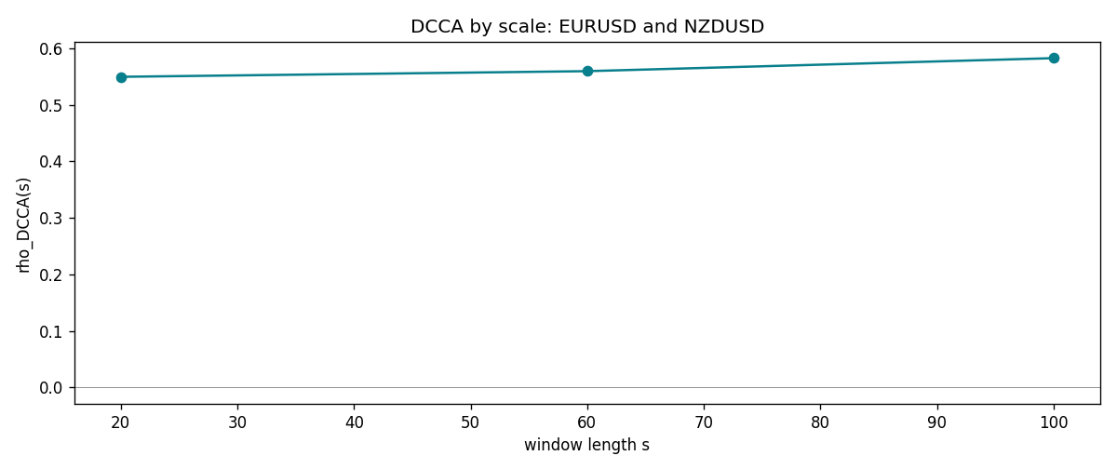

Data report
Matched rows and the scale sheet are in the sibling Excel workbook named EURUSD-NZDUSD_DCCA_D1.xlsx. Embedding all rows as a Word table is impractical; this file holds column summaries and the first and last 15 matched rows.
Columns: time, EURUSD_open, NZDUSD_open, EURUSD_high, NZDUSD_high, EURUSD_low, NZDUSD_low, EURUSD_close, NZDUSD_close, EURUSD_tick_volume, NZDUSD_tick_volume, EURUSD_spread, NZDUSD_spread, EURUSD_real_volume, NZDUSD_real_volume, EURUSD_log_return, NZDUSD_log_return
Column summaries (matched calculation rows)
column | count | mean | std | min | 25% | 50% | 75% | max
EURUSD_open | 7186 | 1.181357 | 0.15085833 | 0.8272 | 1.086165 | 1.16609 | 1.2939475 | 1.5995
NZDUSD_open | 7186 | 0.65641776 | 0.10819833 | 0.3913 | 0.59134 | 0.6684 | 0.7249075 | 0.88218
EURUSD_high | 7186 | 1.1864878 | 0.15145386 | 0.8326 | 1.09024 | 1.17121 | 1.2993075 | 1.6038
NZDUSD_high | 7186 | 0.66033433 | 0.10869188 | 0.3961 | 0.59475 | 0.67202 | 0.72936 | 0.88421
EURUSD_low | 7186 | 1.1763494 | 0.15017707 | 0.8227 | 1.082045 | 1.162475 | 1.2884175 | 1.5865
NZDUSD_low | 7186 | 0.65273031 | 0.10779283 | 0.3897 | 0.5880725 | 0.664185 | 0.720965 | 0.87988
EURUSD_close | 7186 | 1.1813978 | 0.15082738 | 0.8267 | 1.0860425 | 1.16602 | 1.2939725 | 1.5997
NZDUSD_close | 7186 | 0.65649194 | 0.10819527 | 0.3907 | 0.59159 | 0.66842 | 0.725015 | 0.8822
EURUSD_tick_volume | 7186 | 103205.25 | 173535.32 | 218 | 9413.25 | 52774.5 | 99579.75 | 1471626
NZDUSD_tick_volume | 7186 | 68709.014 | 123134.25 | 16 | 5585.5 | 33893.5 | 58510.5 | 1127682
EURUSD_spread | 7186 | 19.350682 | 16.562781 | 0 | 8 | 12 | 27.5 | 50
NZDUSD_spread | 7186 | 30.284303 | 25.649992 | 0 | 9 | 17 | 47.5 | 80
EURUSD_real_volume | 7186 | 4.0330482e+10 | 1.6691688e+11 | 0 | 0 | 0 | 0 | 3.6149665e+12
NZDUSD_real_volume | 7186 | 1.6701379e+10 | 8.497804e+10 | 0 | 0 | 0 | 0 | 2.705649e+12
EURUSD_log_return | 7186 | -4.99e-06 | 0.00579654 | -0.03123819 | -0.00323792 | 0 | 0.00325328 | 0.03433183
NZDUSD_log_return | 7186 | 9.3e-06 | 0.0076423 | -0.07027433 | -0.00425367 | 0.00022883 | 0.00457975 | 0.05966839
First 15 matched rows (selected columns)
time | EURUSD_log_return | NZDUSD_log_return
1999-01-05 | -0.0048360507 | -0.0018597736
1999-01-06 | -0.011547966 | 0.0020455609
1999-01-07 | 0.0076280636 | 0.0062963171
1999-01-08 | -0.010902799 | -0.00055396548
1999-01-11 | -0.007103287 | 0.010290425
1999-01-12 | 0.0045103728 | -0.0053157489
1999-01-13 | 0.010845346 | -0.0099742238
1999-01-14 | 0 | -0.00018564931
1999-01-15 | -0.010153245 | -0.00074294208
1999-01-18 | 0.0036256946 | -0.0018597736
1999-01-19 | -0.00017235436 | 0.0018597736
1999-01-20 | -0.0031939256 | 0.0040793678
1999-01-21 | 0.0030215416 | 0.0040627941
1999-01-22 | -0.0012075213 | -0.012051689
1999-01-25 | -0.0030251979 | -0.0035504102
Last 15 matched rows (selected columns)
time | EURUSD_log_return | NZDUSD_log_return
2026-10-13 | 0.0037402957 | 0.0047326165
2026-10-14 | -0.0037582255 | -0.0037306483
2026-10-15 | 0.0056053107 | 0.0047634855
2026-10-16 | 0.0017724895 | 0.0057501001
2026-10-19 | -0.0025394633 | 0.0018917133
2026-10-20 | 0.0023881672 | 0.0037199341
2026-10-21 | -0.00032046717 | 0.0030923331
2026-10-22 | -0.0015949606 | -0.0033035227
2026-10-23 | -0.001338521 | 0.0030929853
2026-10-26 | -0.0022706559 | -0.0028993932
2026-10-27 | -0.004152342 | -0.00026399852
2026-10-28 | 0.0022262927 | -0.0097283914
2026-10-29 | 0.0022571351 | 0.00062190714
2026-10-30 | -0.0011458446 | 0.00019537668
2026-11-02 | 0.002120569 | -0.0025962955

